TUTORIAL 4 – SCREENSHOT REPORT
FUNCTIONAL & NON-FUNCTIONAL TESTING
Website: Automation Exercise
This report covers the ten Login test cases required for Tutorial 4. The wording is kept simple and practical for a student lab record.
TC01 – Valid Login
Test Case | Verify that a registered user can log in with correct credentials.
Execution | Open Login → Enter registered email → Enter correct password → Click Login
Test Data | Registered email / correct password
Expected Result | User should log in successfully and the logged-in username should be visible.
Actual Result | Login is successful and the logged-in username is displayed.
Status | PASS
Screenshot:
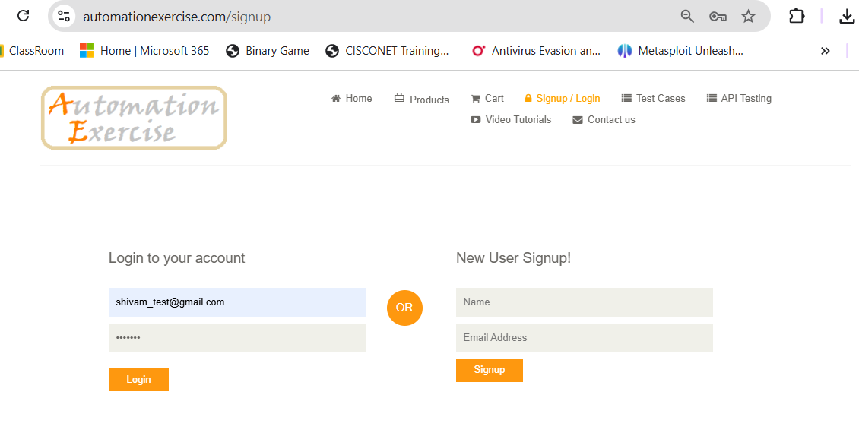
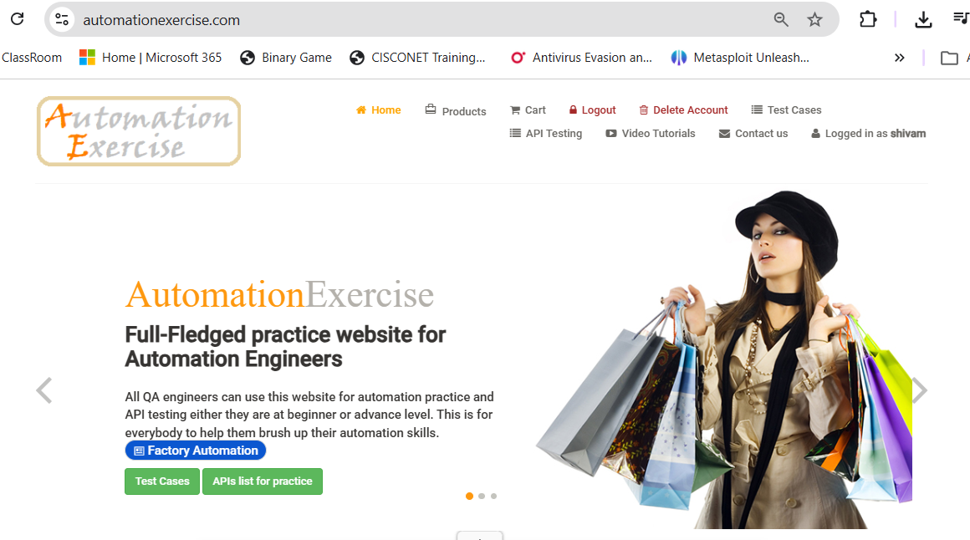

TC02 – Invalid Email
Test Case | Verify that login is rejected when an incorrect email is entered.
Execution | Enter incorrect email → Enter password → Click Login
Test Data | wrong-email@example.com / valid password
Expected Result | An error message should be displayed and login should not be completed.
Actual Result | Login is rejected and the error message is displayed.
Status | PASS
Screenshot:
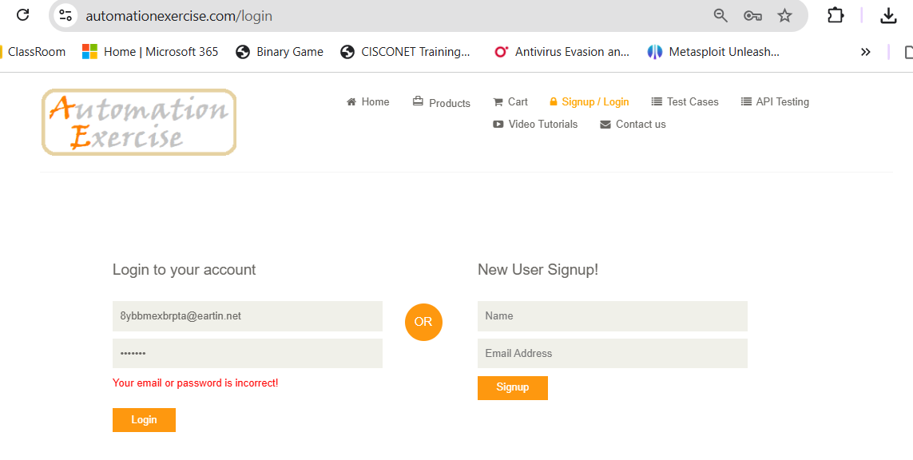

TC03 – Invalid Password
Test Case | Verify that login is rejected when the password is incorrect.
Execution | Enter registered email → Enter wrong password → Click Login
Test Data | Registered email / wrong password
Expected Result | An error message should be displayed and login should not be completed.
Actual Result | Successfully login with incorrect password.
Status | Fail
Screenshot:
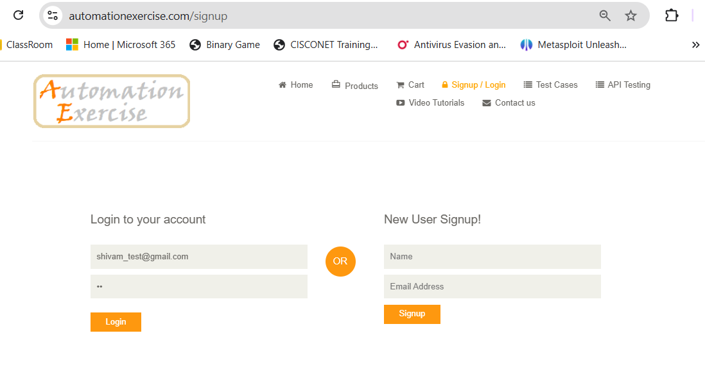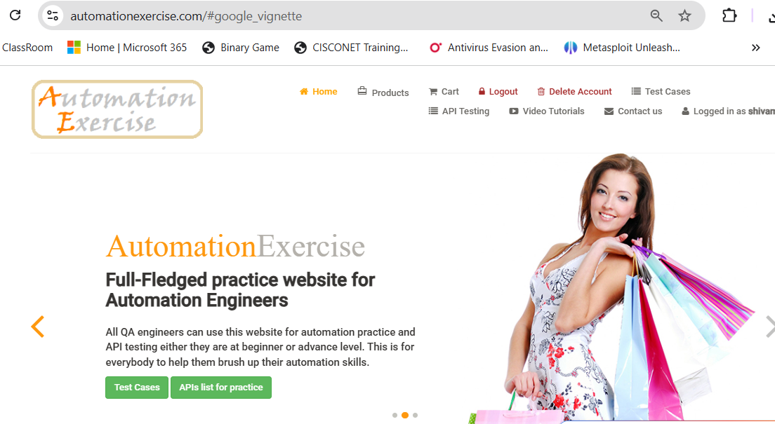

TC04 – Both Invalid
Test Case | Verify that login is rejected when both email and password are incorrect.
Execution | Enter incorrect email → Enter incorrect password → Click Login
Test Data | wrong-email@example.com / wrong123
Expected Result | An error message should be displayed and login should not be completed.
Actual Result | Login is rejected and the error message is displayed.
Status | PASS
Screenshot:
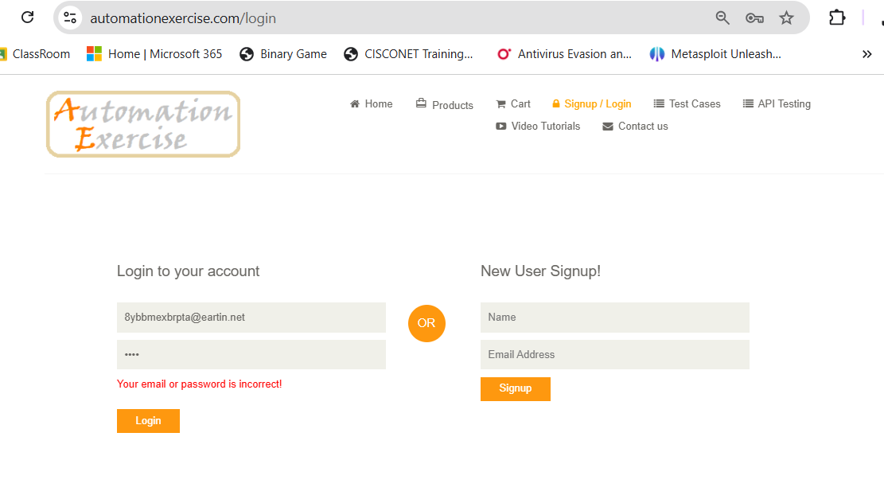

TC05 – Blank Email
Test Case | Verify that login does not proceed when the email field is blank.
Execution | Leave email blank → Enter password → Click Login
Test Data | Blank email / Test@12345
Expected Result | Login should not be successful and validation should be shown.
Actual Result | Login does not proceed with a blank email.
Status | PASS
Screenshot:
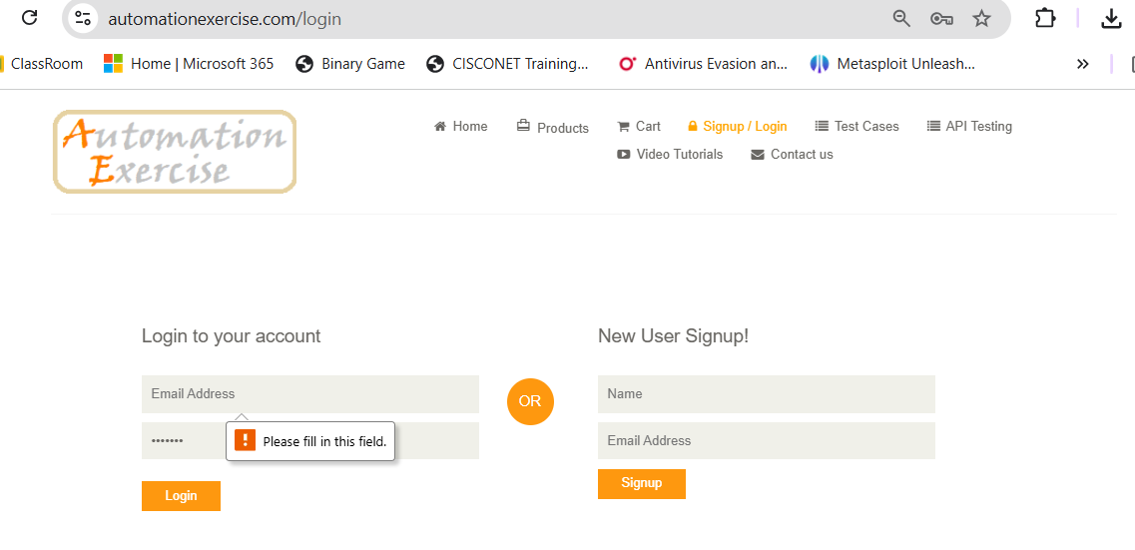

TC06 – Blank Password
Test Case | Verify that login does not proceed when the password field is blank.
Execution | Enter registered email → Leave password blank → Click Login
Test Data | Registered email / blank password
Expected Result | Login should not be successful and validation should be shown.
Actual Result | Login does not proceed with a blank password.
Status | PASS
Screenshot:
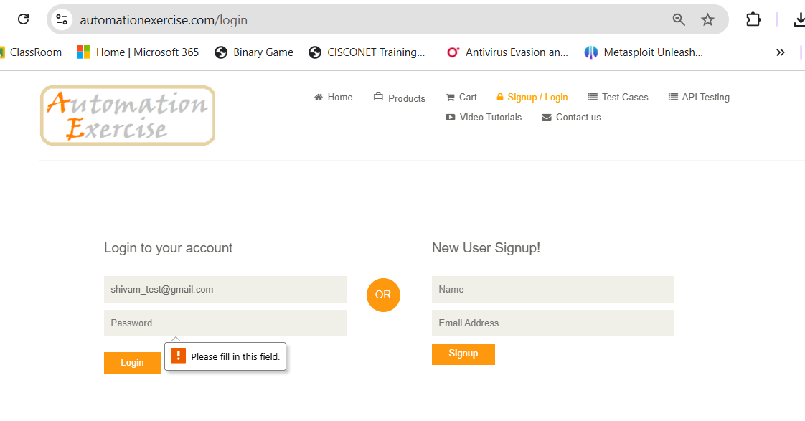

TC07 – Both Blank
Test Case | Verify that login does not proceed when both fields are blank.
Execution | Leave email and password blank → Click Login
Test Data | Blank email / blank password
Expected Result | Login should not be successful and validation should be shown.
Actual Result | Login does not proceed with both fields blank.
Status | PASS
Screenshot:
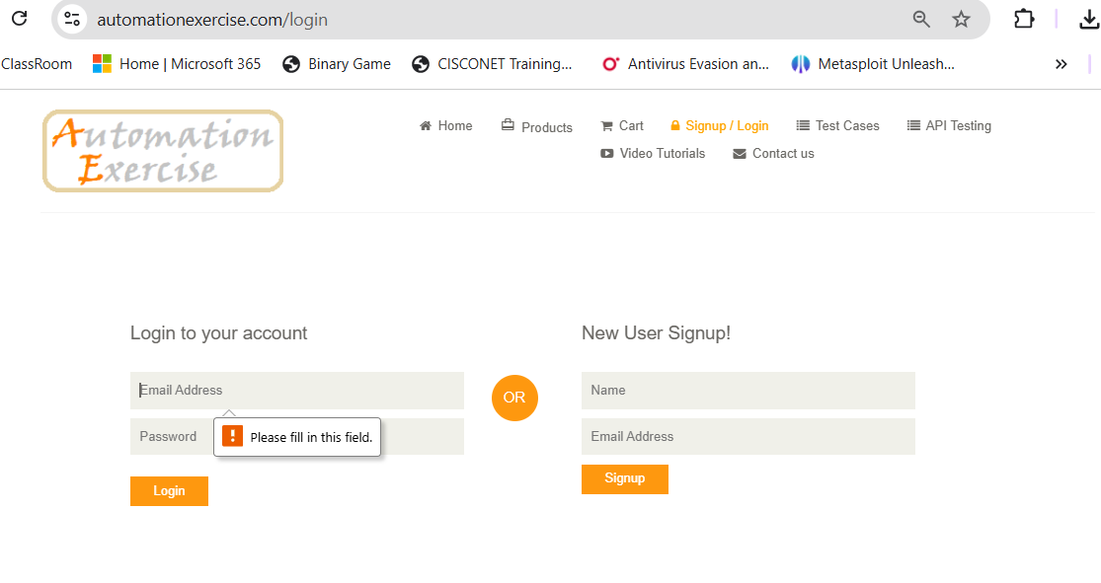

TC08 – Browser Compatibility
Test Case | Check whether the login page and basic login controls work properly in supported browsers.
Execution | Open the login page in Chrome → Check fields/buttons → Repeat in another supported browser
Test Data | Chrome / Edge
Expected Result | Login page should load properly and controls should work consistently.
Actual Result | Login page and controls are usable in the checked browsers.
Status | PASS
Screenshot:

TC09 – Usability
Test Case | Check whether the login page is simple and easy to use.
Execution | Observe labels → Enter details → Check navigation and error feedback
Test Data | Normal valid/invalid login inputs
Expected Result | Fields, buttons and messages should be easy to understand and use.
Actual Result | The login page is simple to understand and the controls are easy to use.
Status | PASS
Screenshot:

TC10 – Page Layout
Test Case | Check whether the login page layout is displayed properly.
Execution | Open login page → Check headings, input fields, buttons and alignment
Test Data | Login page
Expected Result | All main elements should be visible, aligned and readable.
Actual Result | The main login elements are visible, aligned and readable.
Status | PASS
Screenshot:
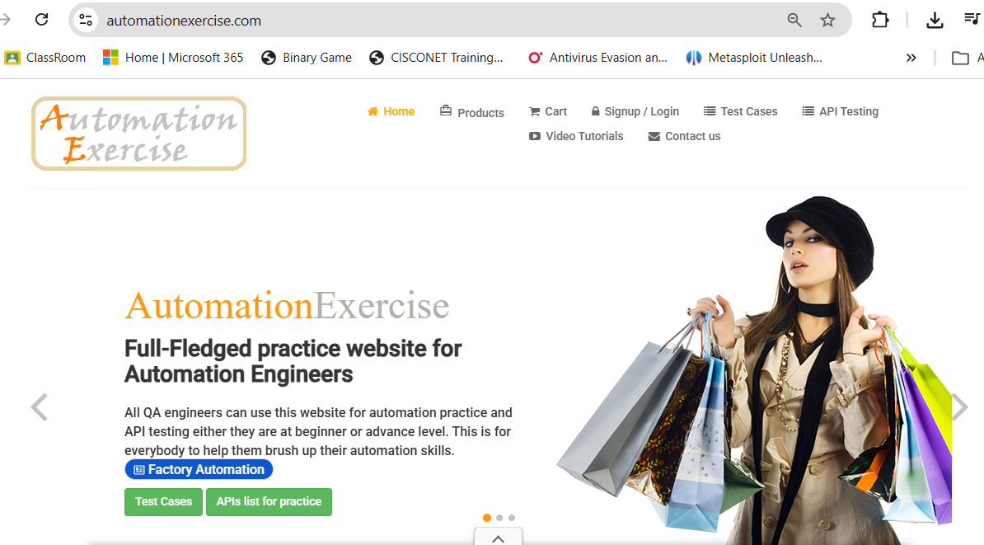

Test Execution Summary
Total Test Cases | 10
Passed | 9
Failed | 1
Blocked | 0
Pass % | 90%
Overall Result | PASS

